**CD Offer Adjustment Recommendations for Suggested Offers v1.r3**

**By William Miller, 7/26/19**

During the first month of testing suggested offers v1.r3, it has become apparent that the suggested offers for CDs have far exceeded chain average. As of 7/23/19, suggested offers for CDs averaged $0.74 per CD, whereas the chain average offer per CD was $0.51.

In order to make a recommendation as to potential adjustments to suggested offers for CDs, I performed the following analysis.

First, I examined the frequency with which CDs sell at particular values of “Days Scanned to Shelf w/ Trash Penalty”.

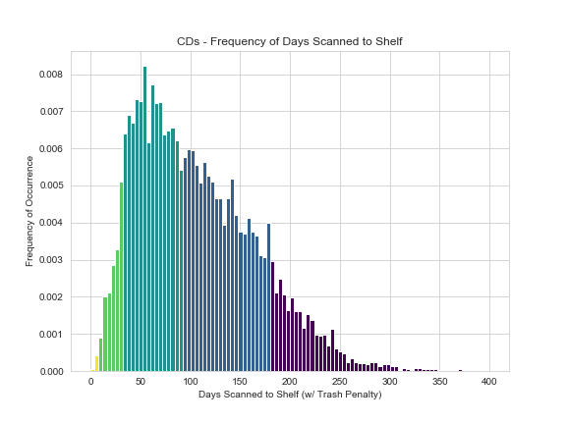

From the above it can be determined that the point at which CD most frequently sell is at a little over 50 days scanned to the shelf after penalty. The majority of CDs sell after 90 days. This indicates that it is likely that merchandise in the dark green and dark blue areas of the chart that primarily determine the average suggested offer for CDs.

Next I examined the frequency with which suggested offer amounts have occurred.

Looking at the frequency of CD suggested offer distribution, it is clear that CDs tend to fall into one of three offer groups: those for which we offer $0.00, those for which we offer around $0.25, and those for which we offer around $1.00. This likely corresponds with buy grades E (0%), D (5%) and C (20%).

I then broke down what quantity of CDs have been purchased for each grade

There are two conclusions that can be made from this breakdown. First, that my hypothesis that the groups of suggested offer amounts correspond to E, D, and C grades is likely correct. Second, that B grade (30%) CD offers tend to overlap with C grade CD offers and have a long trail to the right of the offer frequency distribution.

My next step was to perform the same analysis as the last step but looking at the total dollar amount of CD suggested offers.

The data in this chart represents the actual suggested offers for CDs for all v1.r3 suggested offers. The average suggested offer per CD is $0.76 for a quantity of 17,415 CDs resulting in a total cost of $13,270.20.

It is clear from this breakdown that the majority of offer amounts suggested for CDs has been for C grade (20%) CDs. I hypothesized that adjusting this percentage downwards would likely be the most effective way of normalizing CD costs to chain average. From my buying experience in the stores, I knew that 10% was standardly applied to common CDs.

Finally, I determined what the total expenditure would have been on CDs had 10% been paid instead of 20% on all C grade CDs and calculated the effect of that on average CD cost.

The data in this chart represents the adjusted suggested offers for CDs for all v1.r3 suggested offers.

Had we paid 10% for C grade CDs instead of 20%, the average suggested offer per CD would have been $0.52 for 17,405 CDs resulting in a total cost of $9,118.29. The chain average for CD offers during this time period was $0.51 per CD.

**Conclusion**

CD offers can be normalized to chain average by adjusting the percentage paid for “C” grade CDs from 20% to 10%